Revenue Recognition Layer
Introduction
- Revenue may be recognized either immediately or over time, depending on the revenue recognition rules configured in the system.
- In NetSuite, revenue recognition can occur either:
  - Immediately at the time of invoicing
  - Gradually over time based on predefined recognition schedules
- This behaviour depends on whether Advanced Revenue Management (ARM) is enabled.
- Revenue recognition plays a critical role in ensuring compliance with accounting standards such as:
  - ASC 606 (United States)
  - IFRS 15 (International Financial Reporting Standards)
- Because of this, revenue recognition configuration must align with both operational billing processes and financial reporting policies.

Revenue Recognition Architecture
- Revenue recognition in NetSuite follows a structured processing model.
- This model separates billing activity from revenue recognition timing.
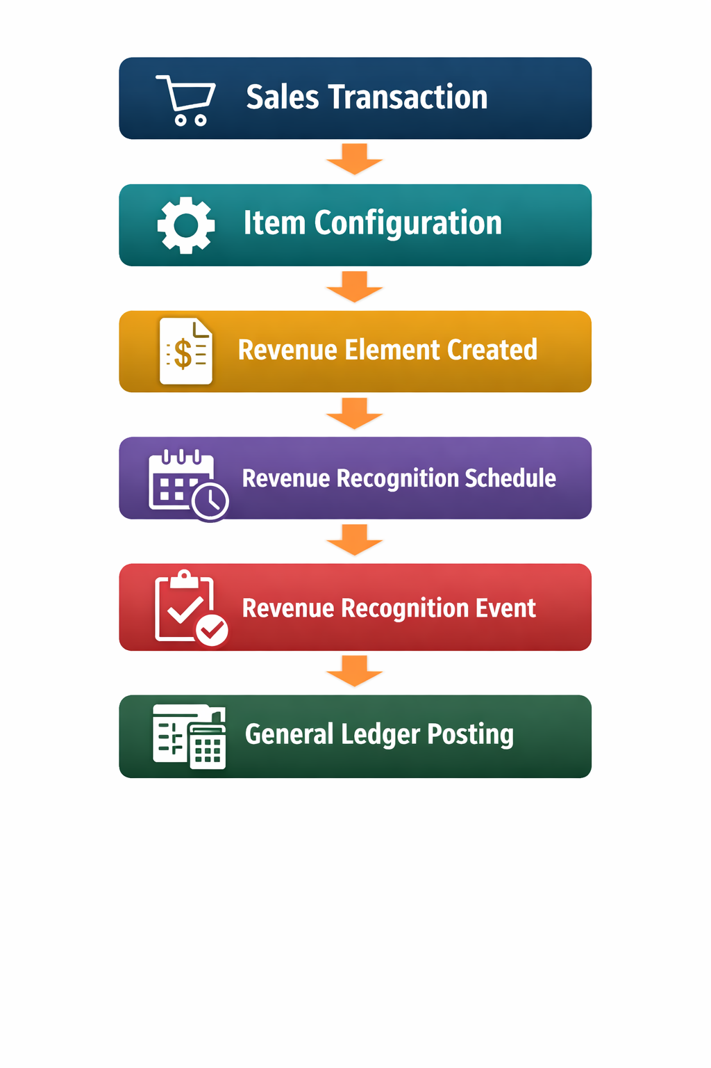
Role of Advanced Revenue Management (ARM)
- When Advanced Revenue Management is enabled, revenue is not always recognized immediately.
- Instead, NetSuite introduces several additional components:
  - Revenue Elements – represent the revenue associated with a transaction line
  - Revenue Recognition Rules – determine how revenue should be recognized
  - Revenue Plans – define the schedule for recognizing revenue
  - Revenue Arrangements – group revenue elements for allocation
- These components allow NetSuite to comply with modern revenue recognition standards.

Revenue Recognition Rules (formerly called templates)
- Revenue recognition templates control how revenue is distributed across accounting periods.
- Templates may define recognition methods such as:
  - Immediate recognition
  - Evenly distributed recognition over time
  - Milestone-based recognition
  - Event-based recognition
Example:
- Contract Value: $12,000
- Recognition Period: 12 months
- Monthly Revenue Recognition = $1,000

Example Financial Flow
- When deferred revenue is used, the accounting entries may appear as follows.
- Invoice Created
  - Dr Accounts Receivable
  - Cr Deferred Revenue
- Revenue is not recognized immediately.
- Revenue Recognition Event
  - Dr Deferred Revenue
  - Cr Revenue
- Revenue is recognized according to the defined schedule.

Revenue Recognition Lifecycle
- The lifecycle of revenue recognition typically follows this sequence.
- During this process, NetSuite may temporarily store revenue in Deferred Revenue accounts before recognizing it as income.
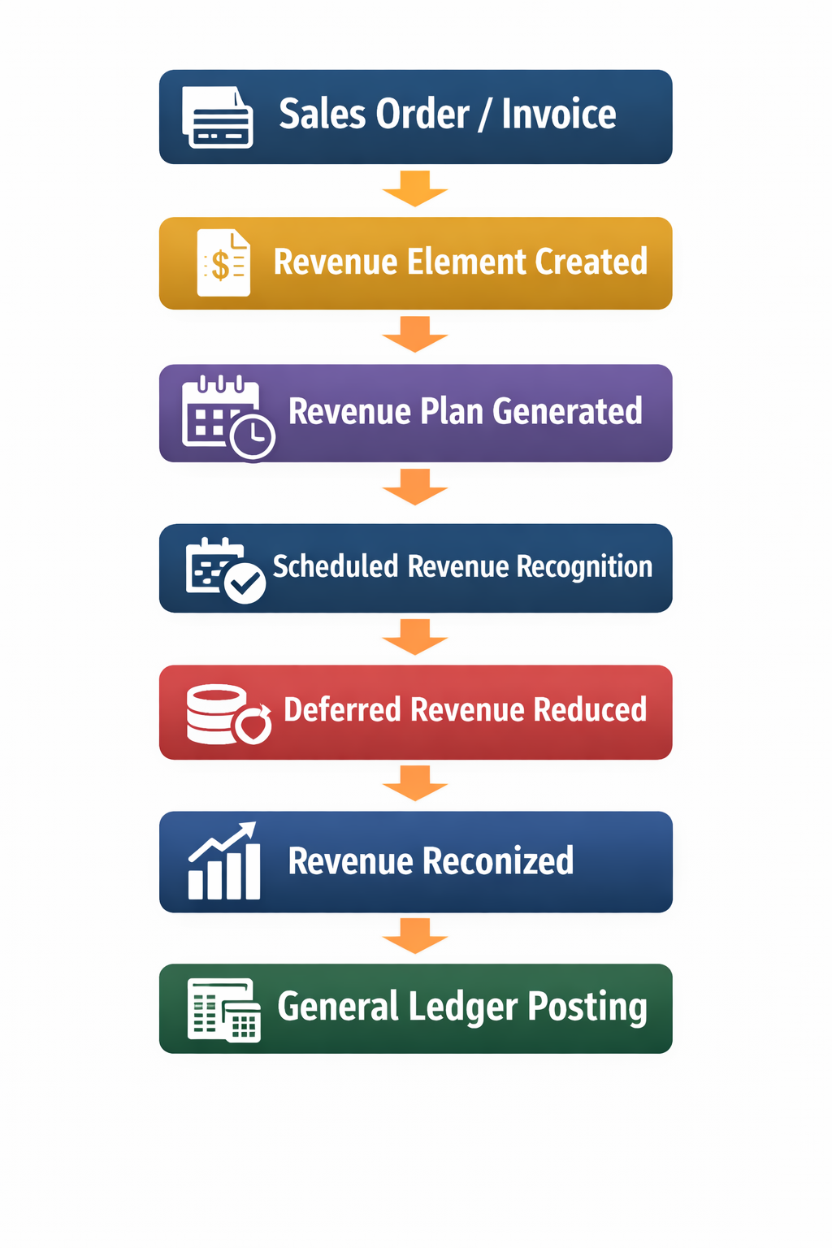
Key Dependencies
- Revenue recognition behaviour depends on several configuration elements.
- Important dependencies include:
  - Item configuration
  - Revenue Recognition Template
  - Billing structure (invoice vs milestone billing)
  - Contract duration
  - Revenue recognition rules
  - Accounting periods
- Changes to these components can significantly alter revenue timing.

Risks and Misconfiguration
- Incorrect revenue recognition configuration can lead to major financial reporting issues.
- Common risks include:
  - Revenue recognized too early or too late
  - Incorrect deferred revenue balances
  - Misalignment with contract obligations
  - Incorrect revenue allocation across bundled items
- These issues may lead to audit findings and financial restatements.

Governance Controls
- Organizations should implement strict governance controls around revenue recognition.
- Recommended controls include:
  - Finance approval of revenue recognition templates
  - Alignment between contracts and recognition schedules
  - Periodic review of deferred revenue balances
  - Monitoring of revenue plans generated by ARM

Architectural Insight
- Revenue recognition separates billing activity from revenue realization.
- While billing determines when customers are invoiced, revenue recognition determines when income is recorded in the financial statements.
- This separation ensures that financial reporting accurately reflects the delivery of goods or services rather than the timing of customer payments.
- When properly configured, NetSuite’s revenue recognition framework enables organizations to comply with modern accounting standards while maintaining transparency in financial reporting.

